PRESS NOTE
World Water Day Celebration at SVNIT, Surat
On the occasion of World Water Day, a workshop on “Securing Water for a Thirsty World: Trends, Threats & Transformation” was successfully organized by the Water Resources and Environmental Engineering Section at Sardar Vallabhbhai National Institute of Technology (SVNIT), Surat.
The program commenced with a brief outline by the Course Coordinator, Dr. S. M. Yadav, Professor, Department of Civil Engineering who highlighted the significance of water in sustaining life and emphasized the urgent need for its conservation and responsible management.
The Head of the Department, Dr. V. L. Manekar, Professor & Head addressed the gathering and shared his valuable insights on the importance of collective efforts in water conservation. He emphasized that sustainable water management is essential for ensuring a secure future.
Dr. Anupam Shukla, Director in his message, highlighted the major artificial recharge activities through more than 33 wells on campus. He further added that crores of liters of water is recharged through these recharge bore wells every year.
The event featured an expert lecture by Dr. Soumendra Kuiry from IIT Madras, who delivered an insightful talk on “Integrated River and Ocean Modelling System (IROMS)”, providing a deeper understanding of advanced modelling approaches for water systems.
Another distinguished speaker, Dr. R. N. Sankhua, former member of the Ministry of Jal Shakti, Government of India, shared his perspectives on the “Future of Water”, highlighting emerging challenges and the need for innovative and policy-driven solutions.
The program also included student presentations on significant water-related themes.
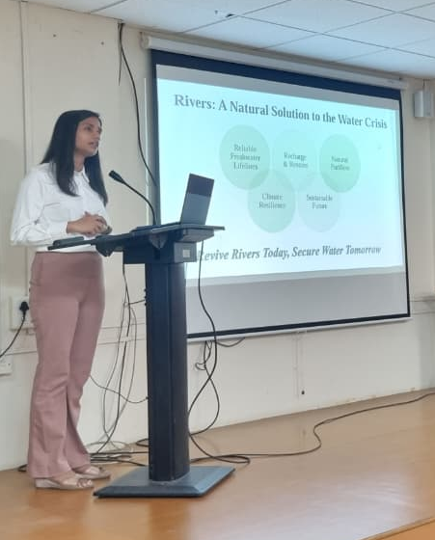 | Ms. Smriti Garg (M.Tech, Environmental Engineering, 2nd Year) presented on “The River Renaissance: Policy Evaluation and the Path to Secure Water for a Thirsty World.” Her presentation covered global water crisis and shows that rivers are the solution to the crisis. The causes and impact of water crisis were discussed. River rejuvenation policy was explained at length.
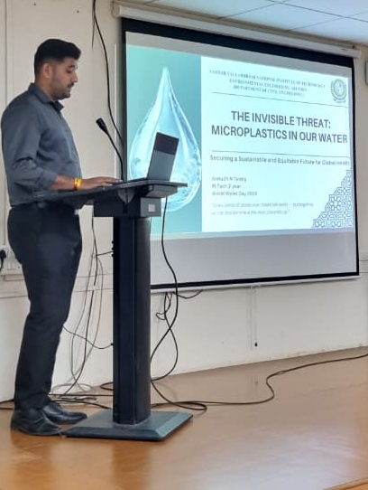 | Mr. Anirudhh Tantri (M.Tech., Environmental Engineering , 2nd Year student) presented an informative talk on “Microplastics.” He shared the harmful effects of micro plastics. How primary and secondary micro plastics enter in to the human body from various sources. The global and Indian scenario on the topic was compared. The solution suggested was the 5R technique i.e. “Refuse, Reduce, Reuse, Recycle, Recover”.
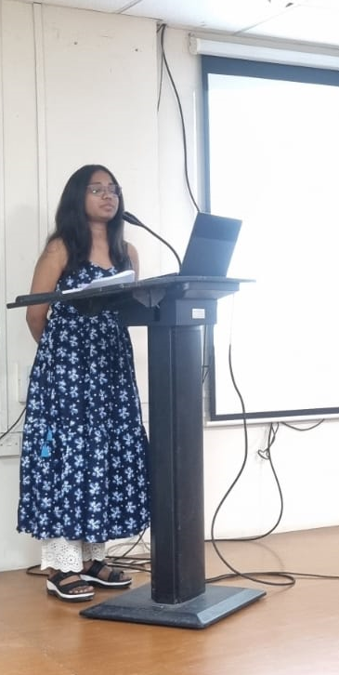 | Ms. Ayushi Panchal (Research Scholar, Water resources Engineering) spoke on “Water and Gender.” This year's UN World Water Day theme, "Water and Gender," emphasizes the disproportionate impact on women. She cited alarming stats: 1 in 5 women lack access to safe drinking water, and women spend 250 million hours daily on water collection, far exceeding men's contributions. Ms.Ayushi stressed the need for inclusive water management, highlighting women's underrepresentation in decision-making roles despite comprising 20% of the water sector workforce. Ms.Ayushi further stated that 156 million girls aged 10-19 still lack access to basic hygiene services globally, compromising their health, dignity and education.
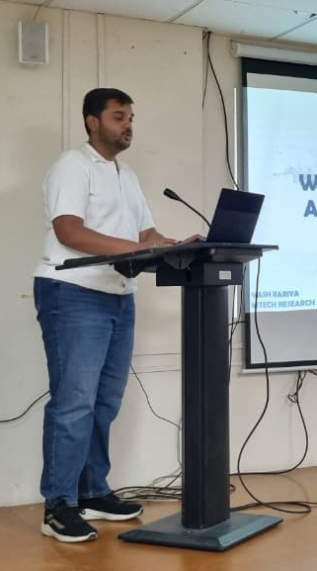 | Mr. Yash Rariya (M.Tech., Water resources Engineering, 2nd Year) presented on “Water Conservation and Artificial Recharge.” He explained the need for conservation of water and what can an individual do to save water on personal level. Artificial recharge of ground water and its need in India due to highly strained resources were discussed. Different methods of artificial recharge practices like surface and sub-surface recharge was explained. Rain water harvesting, its methods and benefits in ground water recharge were covered. The JAL SHAKTI MISSION and ministry’s efforts to conserve every drop of water was highlighted.
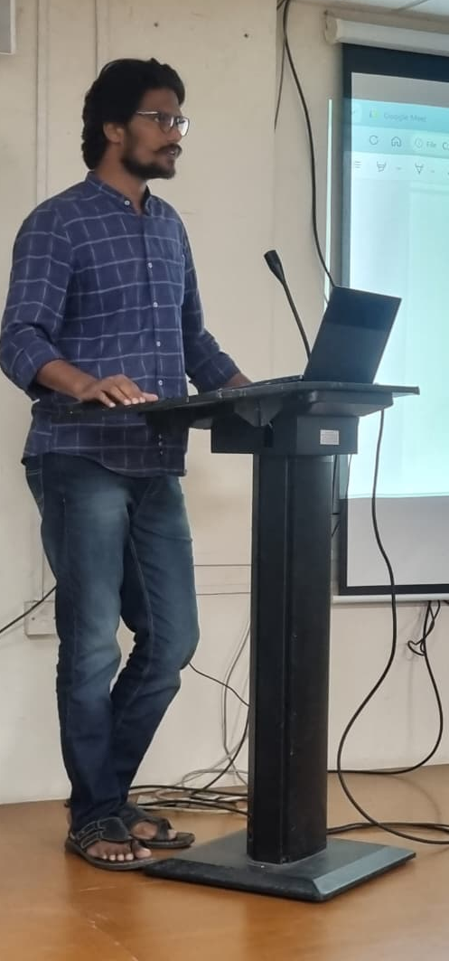 | Mr. Anant Nagar (Research scholar) discussed “Nature-Based Solutions for Water Conservation.” He gave a short speech on the ways in which water can be conserved naturally.
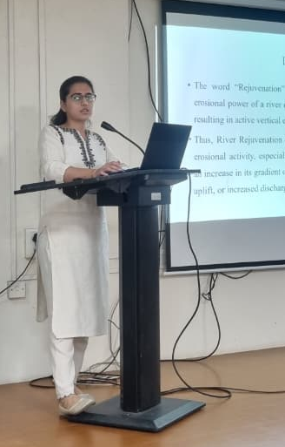 | Ms. Aayushi Jariwala (Research scholar) presented her views on “River Rejuvenation.” The main causes of dying rivers are pollution, dams and barriers, climate change, deforestation and land use land cover changes. The measures like reduce pollution, restoring natural flow, reforestation and afforestation, wetland restorations, sustainable waste management and community engagements are some of the measures to revive the dying rivers.
To make the event more engaging, interactive quizzes and activities were conducted, where participants actively took part and winners were awarded prizes.
Dr. Samaranika Panda, PG In charge, Environmental Engineering, Dr Namarata Jariwala, Associate Professor, Environmental Engineering, Dr .G. D. Kale, Associate Professor, Water Resources Engineering and Dr. P. V. Timbadiya, Professor, Water Resources Engineering encourages the students.
The event concluded with a vote of thanks delivered by Dr. P. G. Agnihotri, who expressed gratitude to all speakers, participants, and organizers for making the program a grand success. The celebration successfully created awareness about the importance of water conservation and inspired participants to contribute towards a sustainable and water-secure future.
